Exercise

1. You must have seen the question before deleting anything like “Are you sure to delete

[Y/y] / [N/n] ? Create a program that asks for this question if user enters Y or y it prints

“Deleted successfully”. If the user enters N or n it prints “Delete cancelled” otherwise it

prints choose the right option using switch statement.

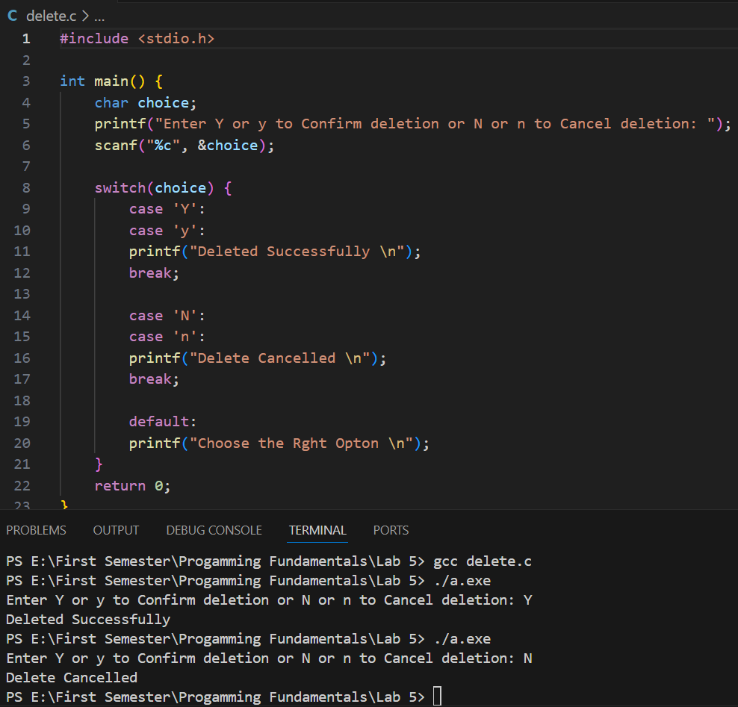

2. Write a program to control a coffee machine. Allow the user to input the type of coffee as B

for Black and W for White. Ask the user if the cup size is double and if the coffee is manual.

The following table details the time chart for the machine for each coffee type. Display a

statement for each step. If the coffee size is double, increase the baking time by 50 percent.

Use functions to display instructions to the user and to compute the coffee time.

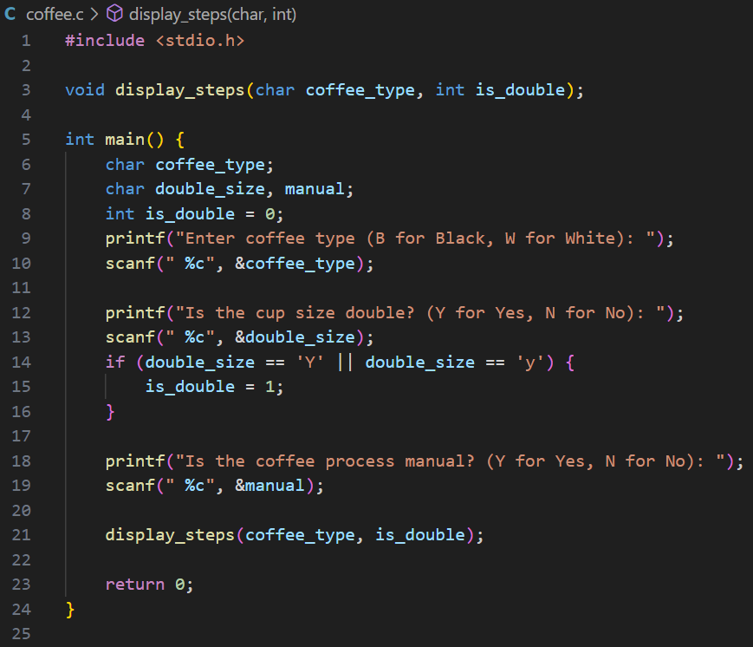

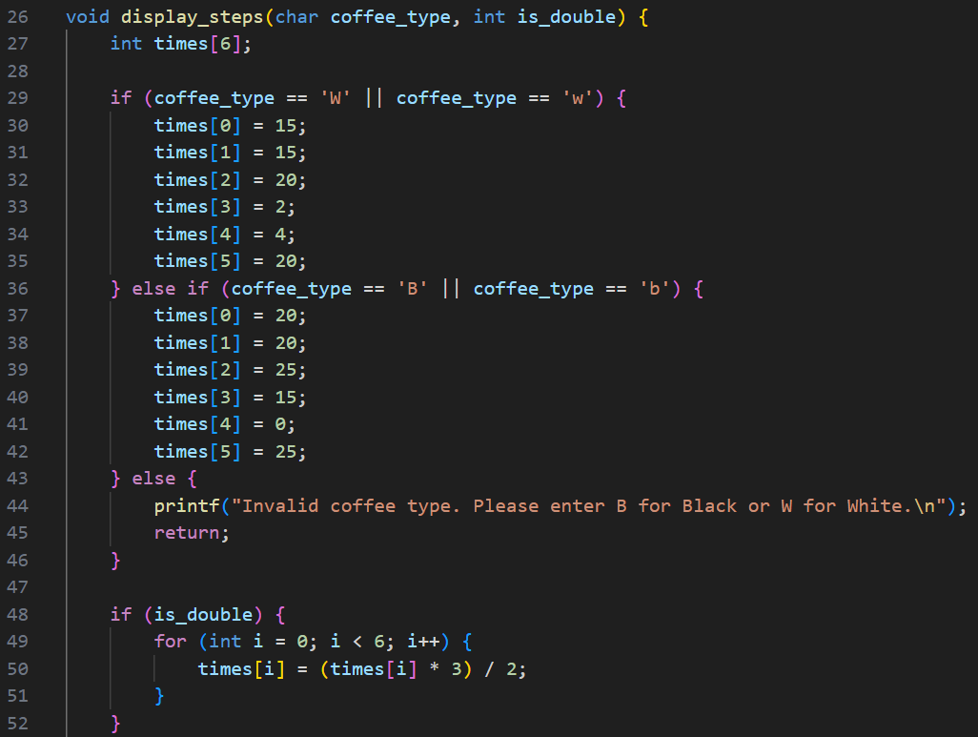

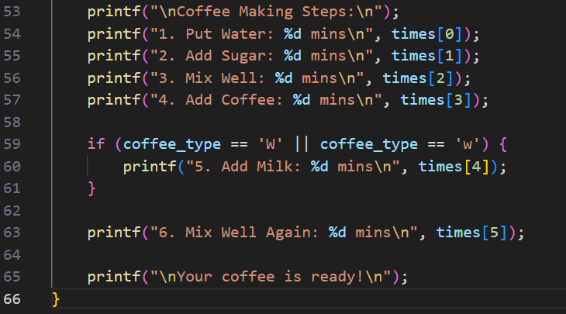

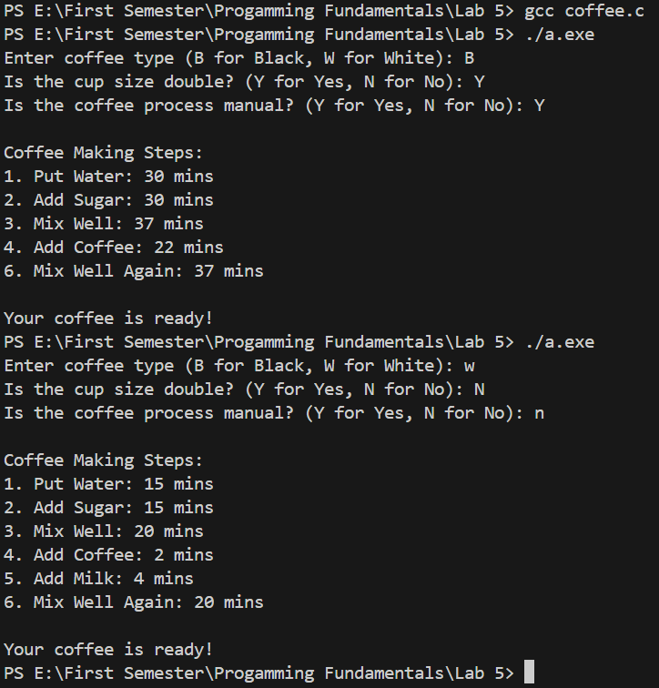

3. Write a program in which user enters his NTS and F.Sc marks and your program will help

student in selection of university. Based on these marks Student will be allocated a seat at

different department of different university.

**Oxford**

IT: Above 70% in Fsc. and 70 % in NTS

Electronics: Above 70% in Fsc. and 60 % in NTS

Telecommunication Above 70% in Fsc. and 50 % in NTS

**MIT**

IT: 70% - 60 % in Fsc. and 50 % in NTS

Chemical: 59% – 50 % in Fsc. and 50 % in NTS

Computer: Above 40% and below 50 % in Fsc. and 50 % in NTS

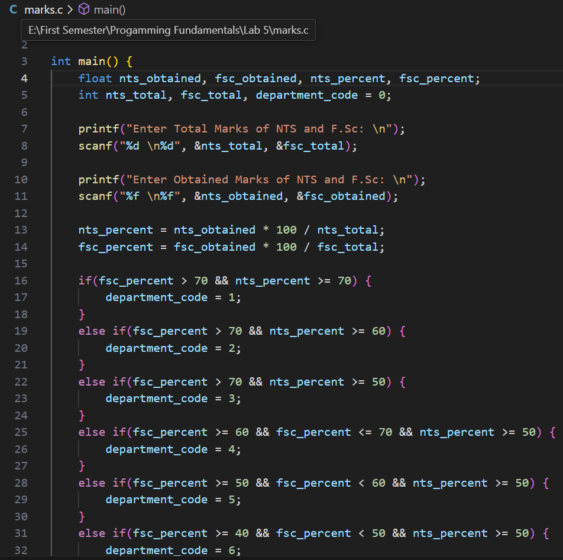

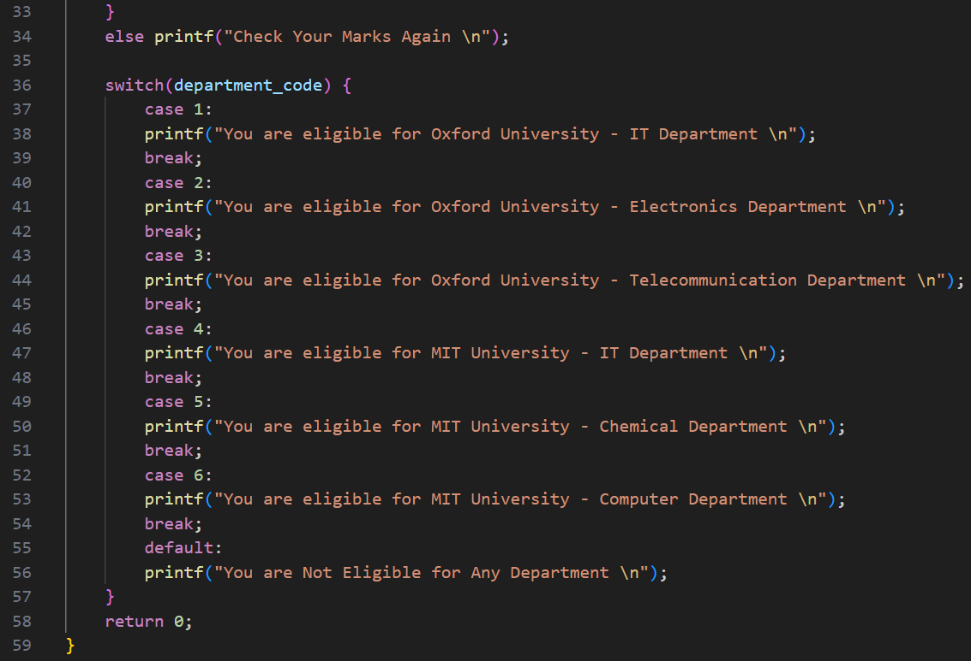

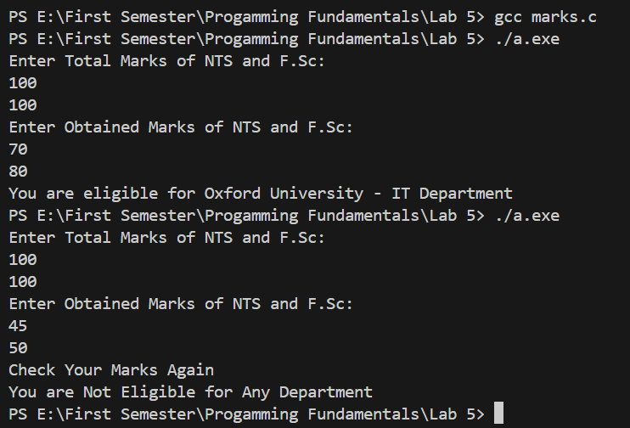

4. Using IF and Switch statement, write a program that displays the following menu for the

food items available to take order from the customer:

B= Burger

(Rs. 200)

F= French Fries

(Rs. 50)

P= Pizza

(Rs. 500)

S= Sandwiches (Rs. 150)

The costumer can order any combination of available food. The program first ask to enter

the no of types of snacks i.e. 2, 3 or 4 then it ask to enter the choice i.e. B for Burger and

then for quantity. The program should finally display the total charges for the order.

